Report of International Seminar on

“Contemporary Technological and Industrial Revolution 5.0”

Date : 05.03.2024

Theme / Objective : To impart knowledge on industrial revolution, technological

advancement and innovation in the industrial sector.

India

No of Beneficiaries : 85
Organized by : PG & RESEARCH DEPARTMENT OF ECONOMICS

Holy Cross College (Autonomous), Nagercoil.
Venue : St. Joseph’s Hall, Holy Cross College (Autonomous),
Nagercoil

P.G and Research Department of Economics, Holy Cross College, Nagercoil organized a one day International seminar “Contemporary Technological and Industrial Revolution 5.0” on 5th March 2024 in the St. Joseph’s Hall. The Inaugural session began with the Prayer Song. Dr. S. Jeni Sanjana, Assistant professor P.G and Research Department of Economics delivered the welcome address.
PHOTO
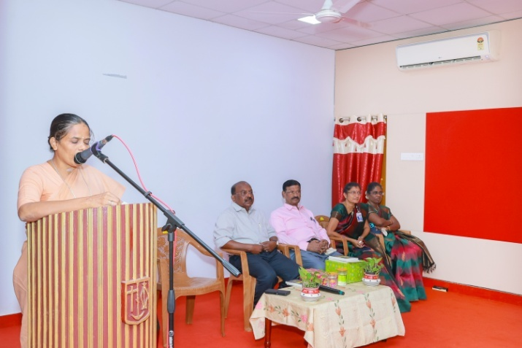

Welcome address by Dr. S. Jeni Sanjana
The Departmental Magazine “ECON-SPECTRUM-2024” was released. The first copy was released by our Guest of Honour Dr. Jebamalai Vinnanchiarrachi, Principal Advisor, Knowledge Managerial Associates, Former Principal Advisor to the Director General of UNIDO, Vienna, Austria and Dr. Sr. Leema Rose, Vice Principal, Holy Cross College, Nagercoil received the first copy and gave a felicitation address. She appreciated the staff members of the P.G and Research Department of Economics for the team work and the skills of the students for the innovative programmes and best practices followed. She also highlighted the importance of industrial revolution and the technological advancement in the recent scenario.
PHTO
PHOTO
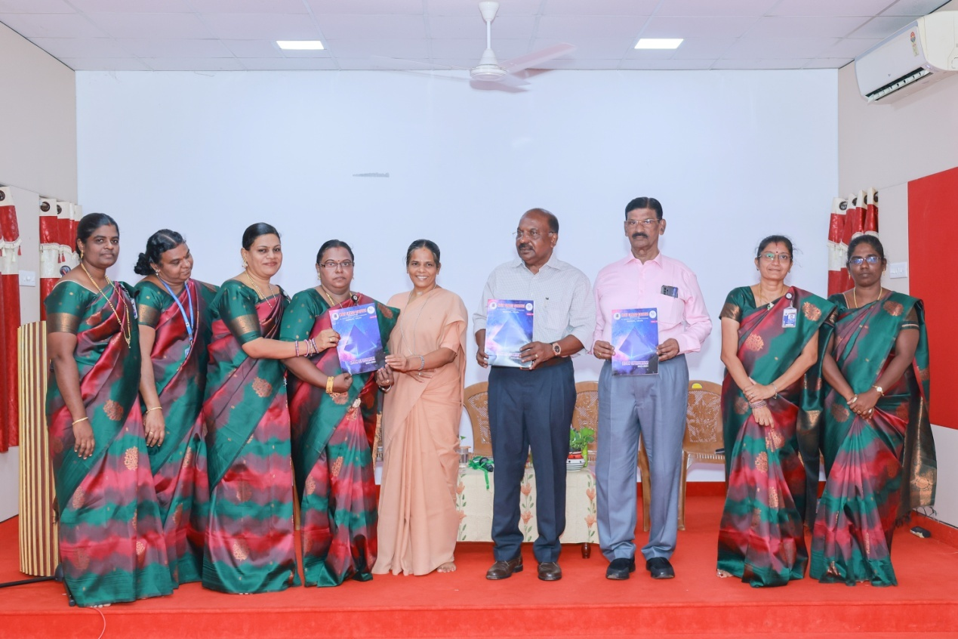

The Guest of Honour Dr. Jebamalai Vinnanchiarachi, Principal Advisor, Knowledge Managerial Associates, Former Principal Advisor to the Director General of UNIDO, Vienna, Austria and the Guest of the day Dr. Veerabahu Kumar , Former Principal, S.T. Hindu College, Nagercoil distributed the prizes for the prize winners of ECON PETALS and ECON BELLS-2024.
PHOTO
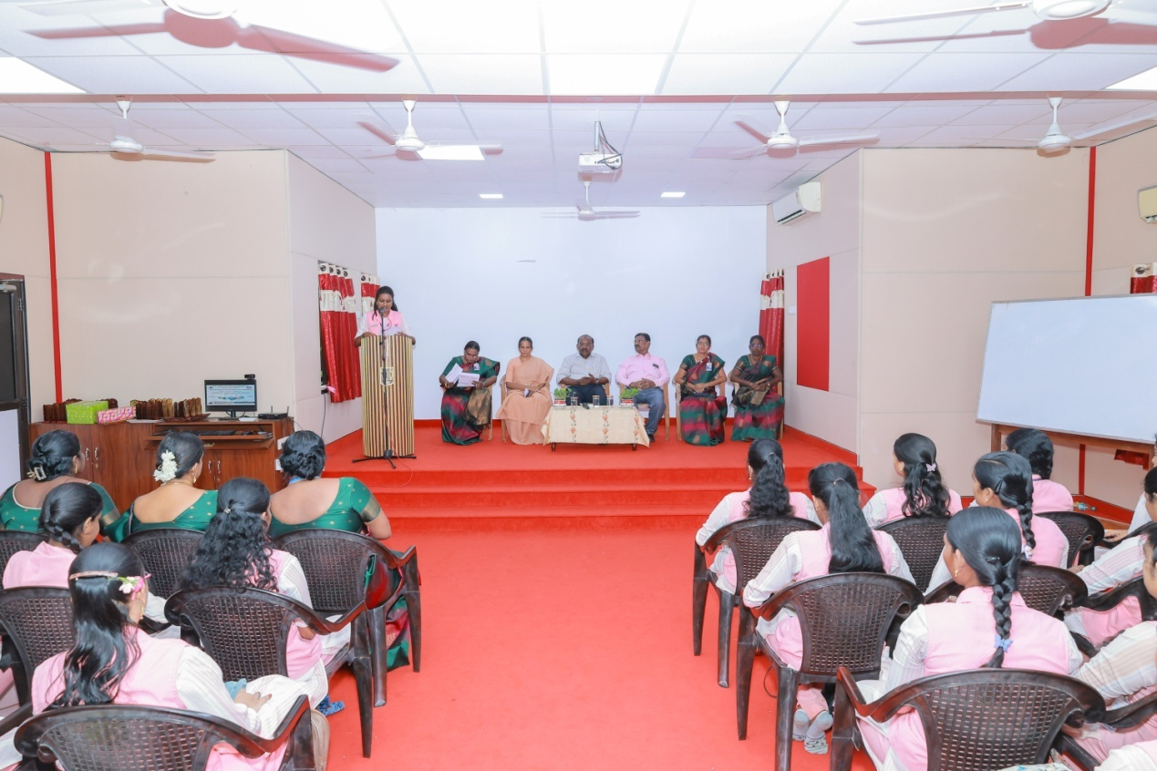

The keynote address was given by Dr.D.G.M.Victoria, Assistant Professor of Economics, S.T.Hindu College, Nagercoil. Dr. Jebamalai Vinnanchiarachi, Principal Advisor, Knowledge Managerial Associates, Former Principal Advisor to the Director General of UNIDO, Vienna, Austria was the resource person. He gave a talk on “The New Era of Creative Destruction and the New Industrial Revolution”. He explained the real situation with the past experiences in the industrial sector. He also highlighted the different types of innovation and the technology advancement with innovation .Dr. J.M.Vinitha Charles, Assistant Professor, Holy Cross College, (Autonomous), Nagercoil proposed the vote of thanks. The event was arranged by the organizing secretaries: Dr.J.M.Vinitha Charles and Mrs. J.Josephine Shiny, Assistant Professors of Economics, Holy cross College (Autonomous) Nagercoil. and Convener Dr.S.Jeni Sanjana, Head of the Department, Holy Cross College, (Autonomous) Nagercoil.

PHOTO
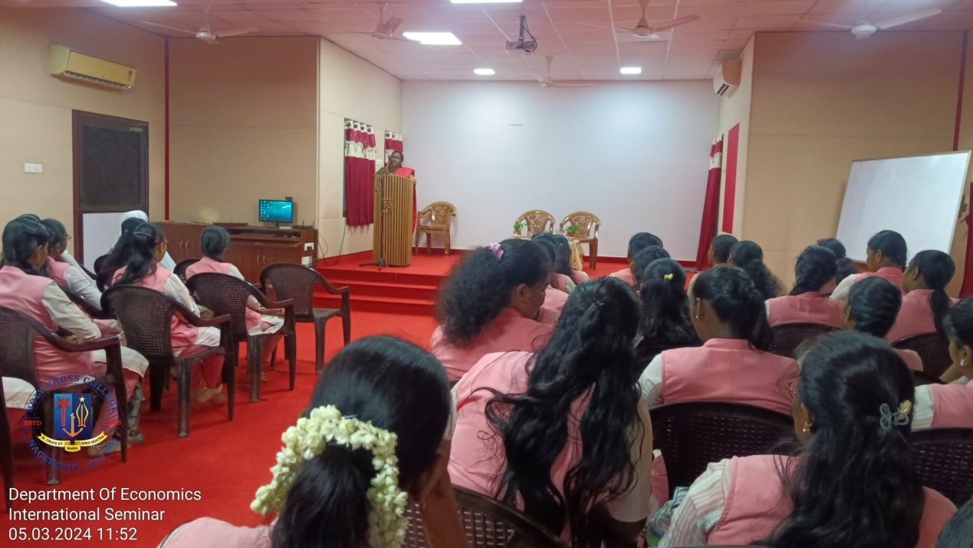
The Technical Session – I was handled by Dr.J.V.Arun, Assistant Professor of Economics, Government Arts College for Men, Nandhanam, Chennai on the topic “ Exploring Industry 5.0: Transformative Technologies for India’s Economic Growth” Dr. S. Panimaya Mercy welcomed the resource person and Dr.A.Sameema proposed the vote of thanks. The seminar came to an end with the National Anthem.
The total number of participants - 85.
PHOTO
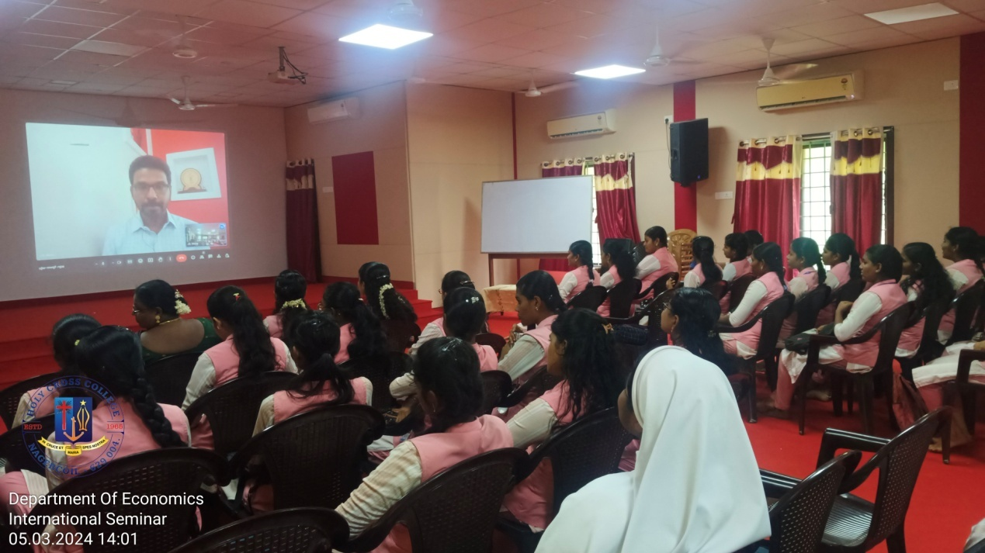
Seminar Invitation

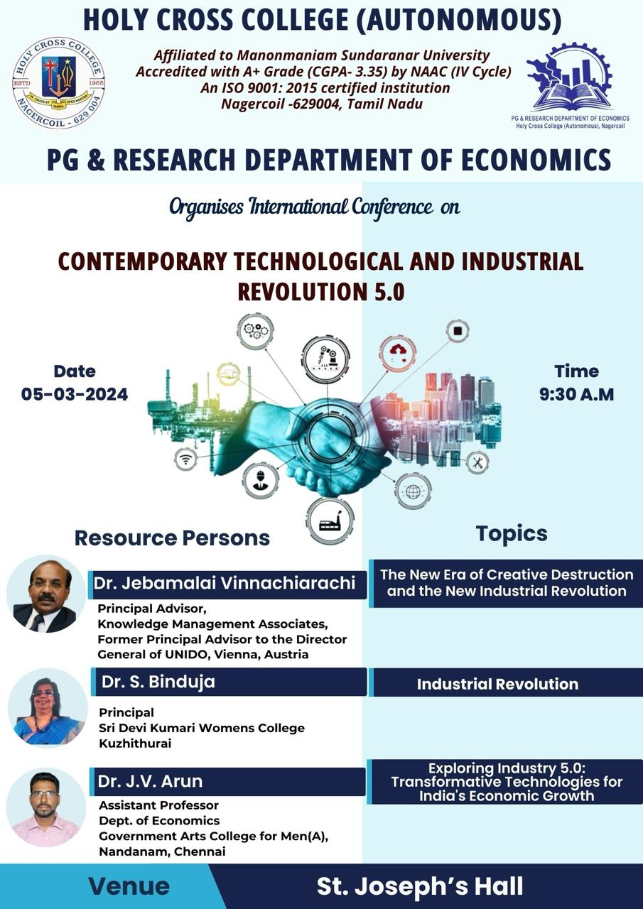
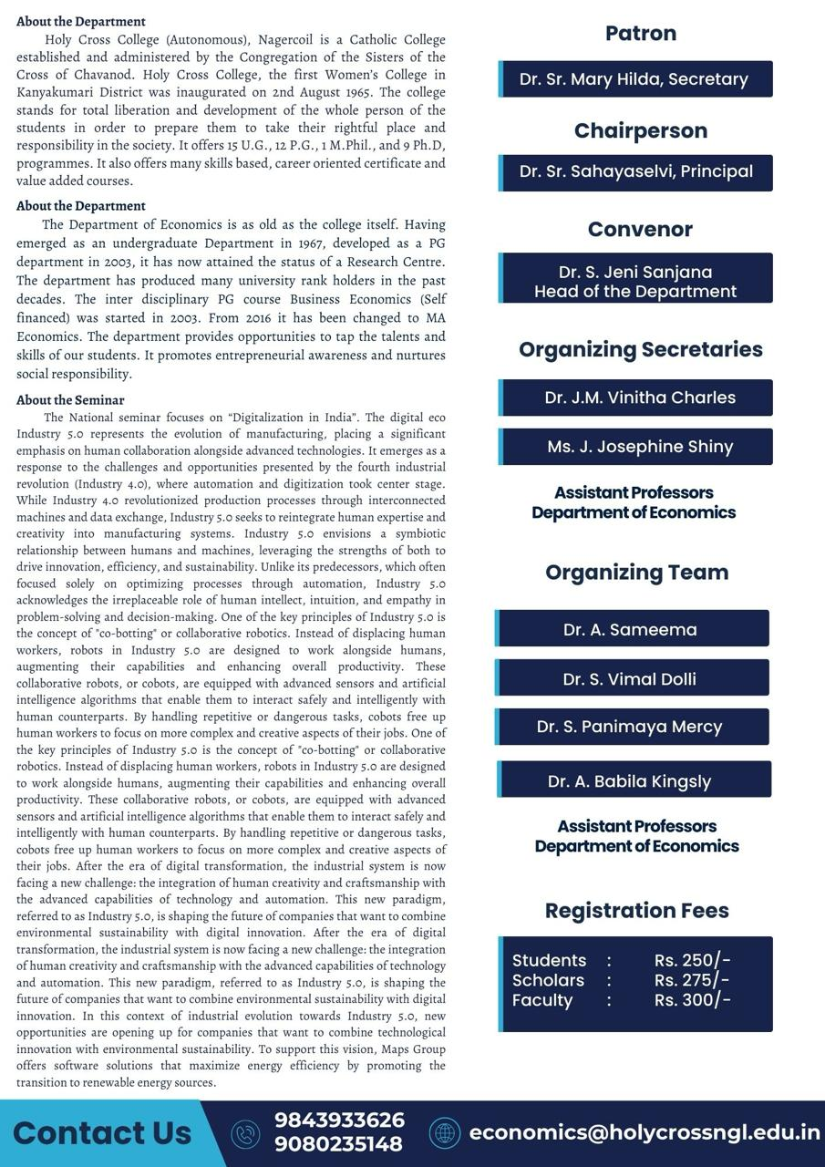

Contemporary Technological and Industrial Revolution 5.0 CONSOLIDATED FEEDBACK FORM
05-03-2024
Department: Economics
S.No | Questions | Excellent | V.Good | Good | Fair | Poor
1 | Selection and Relevance of the topic in the current scenario | 90 | 10 | - | - | -
2 | Choice of the resource person | 90 | 10 | - | - | -
3 | How well did the expert impart their knowledge? | 85 | 10 | 5 | - | -
4 | Time management and audio-visual arrangement | 90 | 5 | 5 | - | -
5 | Overall impression on the International Webinar. | 92 | 5 | 3 | - | -

Certificate

